**Correcting Expense Report Financial Dimensions**

This needs to be done **after hours**

You will get a ticket with an error like this

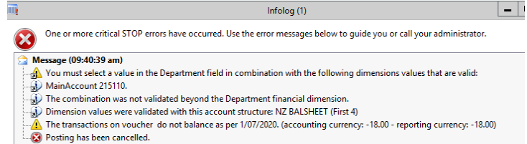

Step 1 – Go to the expense report

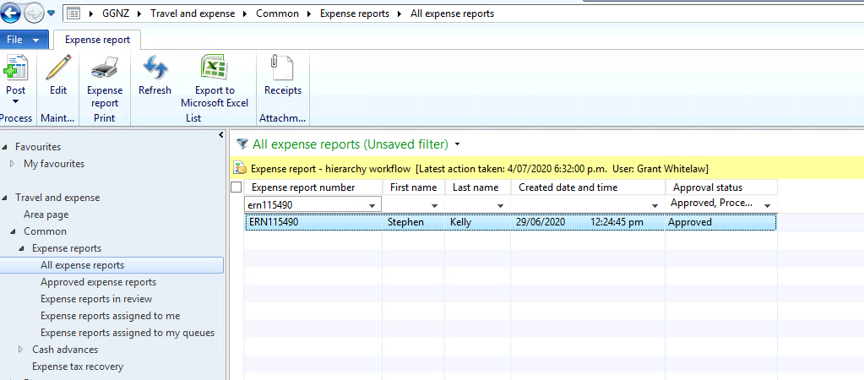

Step 2 – Double click on the expense report, then click on subledger journal

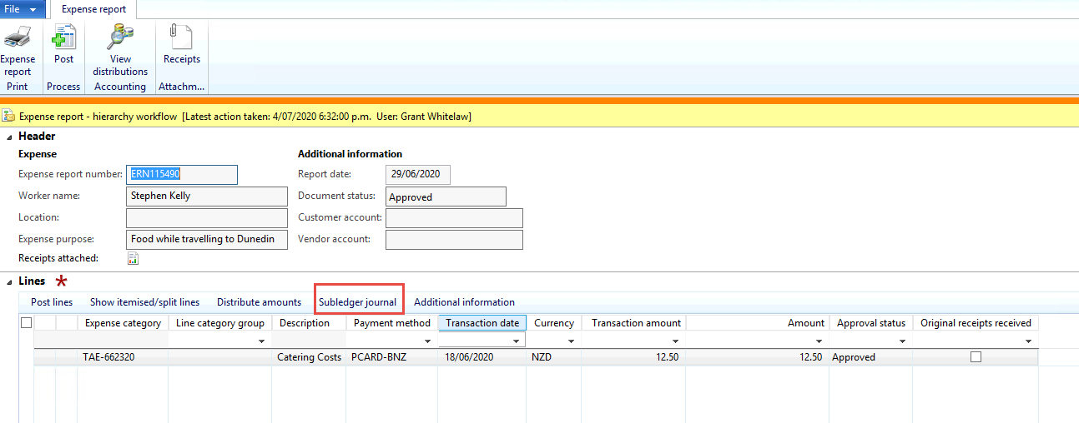

Step 3 – Take a note of the financial dimensions, these will be set as fixed values

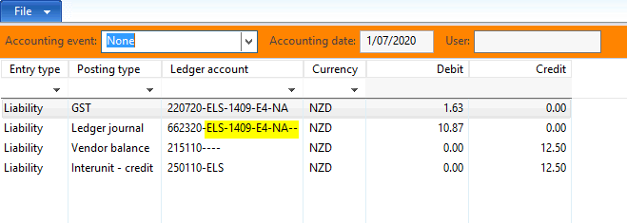

Step 4 – Go to GGNZ/General ledger/Common/Main accounts

Filter for the account 215110 – double click on the account

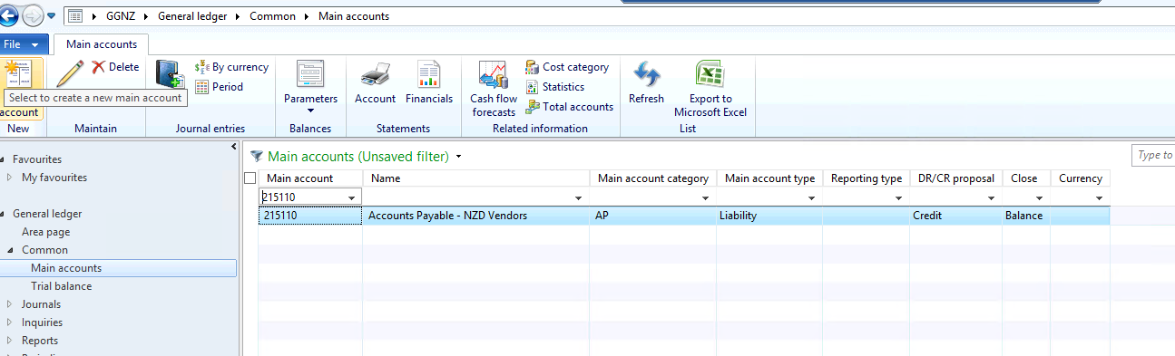

Step 5 – Expand out financial dimensions – click edit

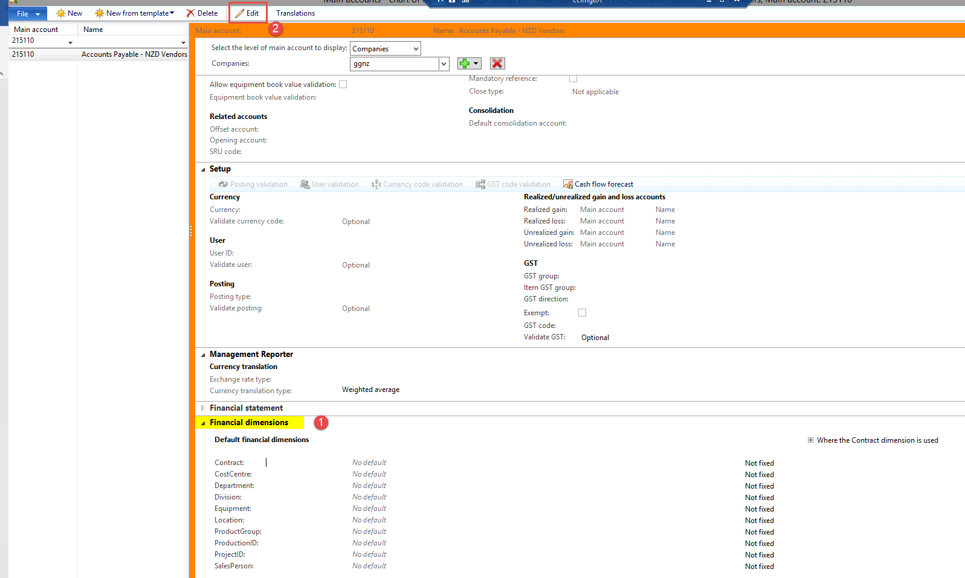

Step 6 – fill out cost centre, department, location and sales person with the values you got earlier – make them all fixed values – click yes

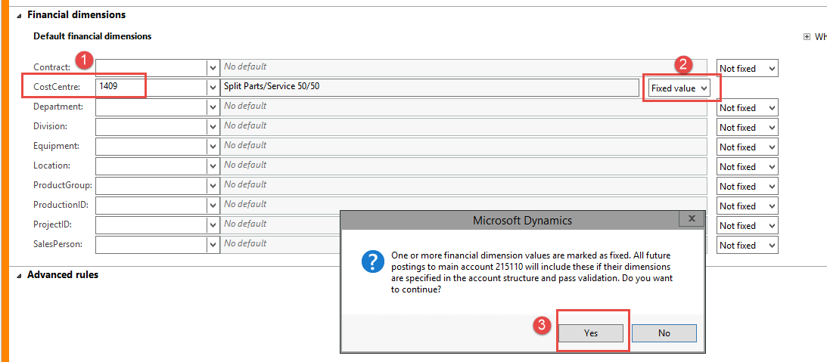

Should look like this

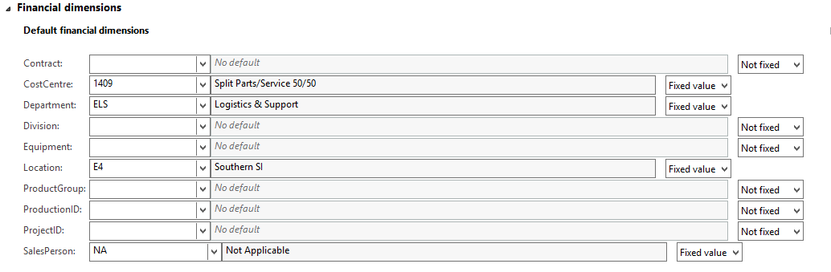

Click close

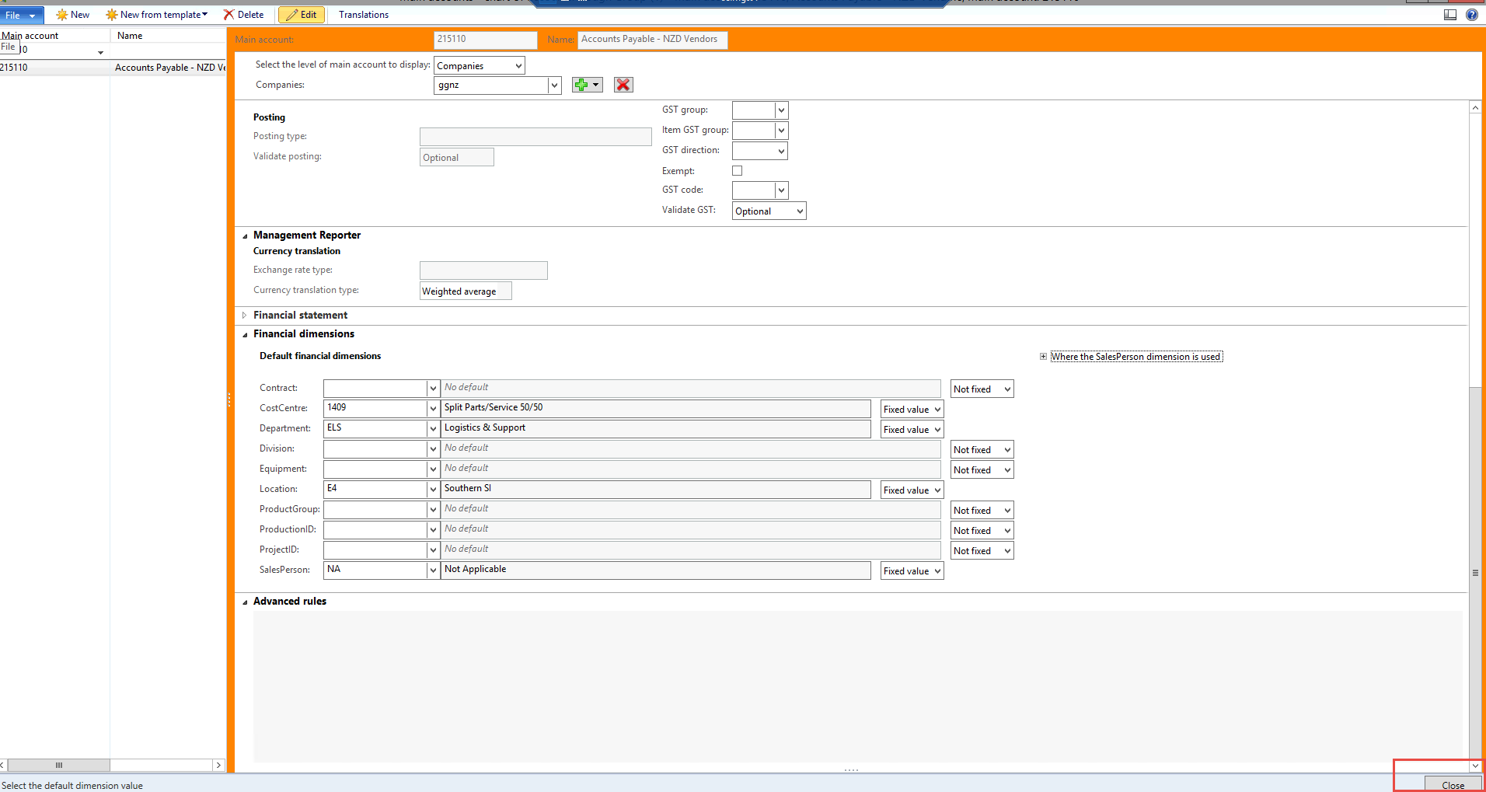

Step 7 – go back to the expense report – double click on it

Then click post

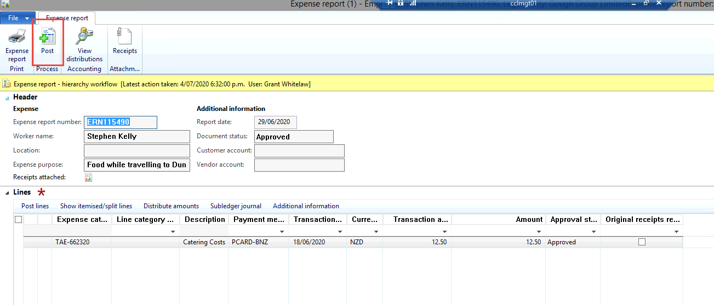

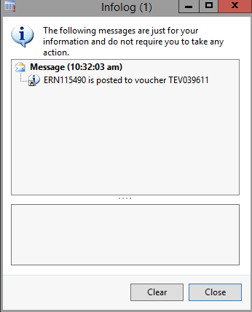

Once posted – go back to general ledger account and remove those financial dimensions from 215110 – **Make sure to change the value to not fixed**